**Tutorial problems-8**

1. Calculate $\int_{1}^{4}{\int_{0}^{3}{\left(3x^{2}y-6xy^{2}\right)dx dy}}$
2. Evaluate the following integrals:

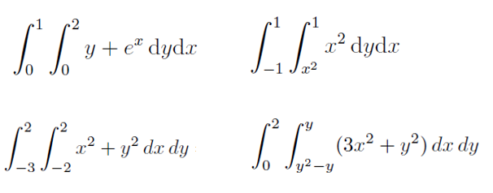

1. Let $D$ be the region described as $D=\left\{0≤y≤2, y≤x≤2\right\}$.

Calculate $\iint_{D}{\left(4-x-y\right) dA}$.

1. Evaluate the integral $\int{\int_{D}{(2x+y)}dx dy}$, where D is the triangle with vertices $\left(0;0\right), \left(2;0\right), \left(4;2\right)$

1. Evaluate the integral $\int{\int_{P}{xy dA}}$, where P is the parallelogram with vertices $\left(0;0\right)$, $\left(3;3\right)$, $\left(3;0\right)$, $\left(6;3\right)$.
2. Evaluate:

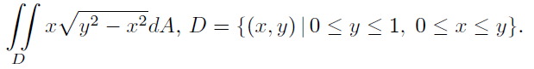

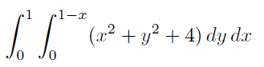

1. Sketch the regions of integration of the following:
$$\int_{1}^{3}{\int_{y}^{4y}{f\left(x, y\right)dx dy}}$$

2. Sketch the region of integration and evaluate the following integral:
$$\int_{0}^{1}{\int_{y}^{\sqrt{y}}{xy^{3}} dx dy}$$

3. Find the following integrals by first interchanging the order of integration:

$a) \int_{0}^{3}{\int_{y}^{3}{e^{x^{2}}}dx dy} ; b) \int_{0}^{9}{\int_{\sqrt{y}}^{3}{\cos{x^{3}dx dy}}}$

1. Evaluate the following integral by first interchanging the order of integration: $$\int_{0}^{2}{\int_{2y}^{4}{e^{x^{2}+1}}dx dy}$$
2. Evaluate the integral:

$$\int_{0}^{\sqrt{2π}}{\int_{0}^{y/2}{4y^{2}\sin{(2xy)}dx dy}}$$